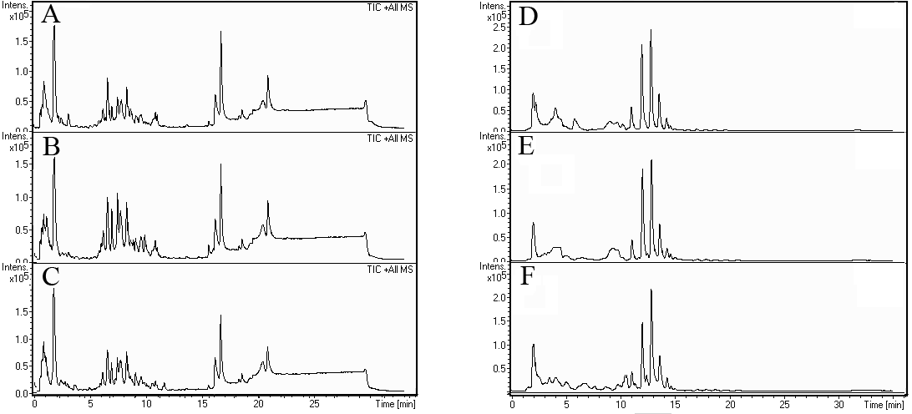
Figure S1. Randomly selected urine profiles in RP mode from A, bladder cancer; B, healthy controls; C, kidney cancer. Representative urine profiles in HILIC mode from D, bladder cancer; E, healthy controls; F, kidney cancer.

Table S1. Reproducibility evaluation based on selected peaks
Peak NO. | RPLC |  |  |  |  | HILIC
Peak NO. | t_{R (min)} | m/z | S.D.t_{R}ª | %RSD^{b} |  | t_{R (min)} | m/z | S.D.t_{R}ª | %RSD^{b}
1 | 1.77 | 265.1 | 0.02 | 2.1 |  | 3.35 | 265.1 | 0.02 | 2.4
2 | 6.53 | 286.2 | 0.04 | 4.1 |  | \ | \ | \ | \
3 | 9.57 | 310.2 | 0.02 | 4.4 |  | 10.22 | 310.2 | 0.04 | 5.2
4 | 16.18 | 577.1 | 0.01 | 1.9 |  | \ | \ | \ | \
5 | 19.54 | 284.3 | 0.01 | 3.1 |  | \ | \ | \ | \
6 | \ | \ | \ | \ |  | 6.12 | 166.1 | 0.06 | 6.8
7 | \ | \ | \ | \ |  | 11.99 | 340.3 | 0.03 | 2.7
8 | \ | \ | \ | \ |  | 13.57 | 453.4 | 0.03 | 2.9
ªstandard deviation of retention times in 12 QC samples.
^{b}relative stand deviation of peak areas in 12 QC samples.

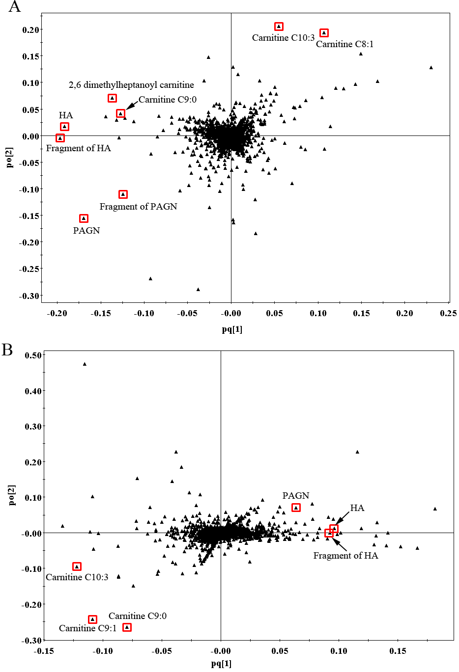
Figure S2. A, loading plot for BC vs. healthy controls model. B, loading plot for KC vs. healthy controls.

The variations of m/z values for all 8 compounds were less than 10 mDa. Standard deviations (S.D.) of retention times (tR) were less than 0.1 min for both chromatographic modes. RSDs of peak areas ranged from1.9% to 4.4% for RPLC and 2.7% to 6.8% for HILIC. These results demonstrated the excellent stability and reproducibility of the chromatographic separation and mass measurement.

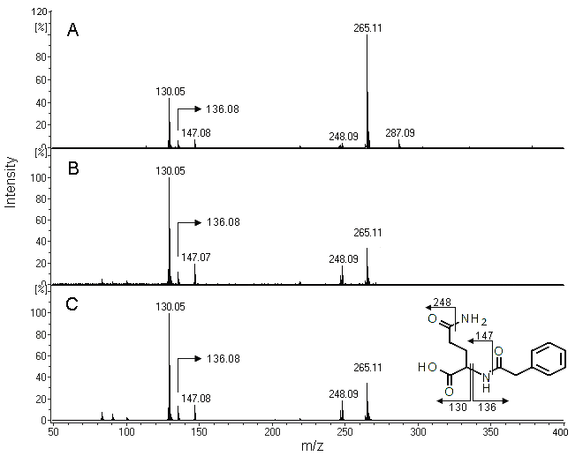
Figure S3. Identification of representative metabolite (m/z 265.11, t_{R}= 1.8 min in RPLC). A, MS spectrum in extracted ion chromatogram. B, MS/MS spectrum of the metabolite. C, MS/MS spectrum of standard phenylacetylglutamine (PAGN). The collision energy was set at 10 eV.
Here, we take the ion of m/z 265.11 as an example to illustrate the process. First, we determined the quasi-molecular weight. The corresponding peak from RPLC was found according to the retention time in EIC of m/z 265.11. Several additional ions were present (ions m/z 130.05, 136.08, 248.09, and 287.09) in the MS spectrum (Figure S2, A). Those ions always have a close relationship to the precursor ion [M+H] ⁺. Ions of m/z 287.09 are [M+Na] ⁺ that usually coexist with [M+H] ⁺ in EIC. C13H17N2O4 was calculated according to the exact mass and the isotope pattern by the assistant software packed in Data Analysis 4.0 (Bruker). Then, based on the comparison to the information from literature and open database, PAGN was identified as the most likely candidate. Additional MS/MS experiments were performed in succession with the spectrum shown in (Figure S2, B). Several fragments can be well fitted to PAGN, as indicated in the insert. Finally, a PAGN standard was purchased, and the MS/MS result (Figure S2, C) was used to ultimate validate the identification. Other metabolites in Table 2 were confirmed based on similar procedures. Two potential biomarkers were unidentifiable due to the restrictions of current metabolite databases.

